**Experiment-4**

**Title:** Jenkins pipeline using BlueOcean Plugin

**Aim:** To create a Jenkins pipeline using BlueOcean plugin with multiple stages (Build, Test and Deploy).

**Pre-Requisites:**

* Apache Maven 3.3.9 or above installed and configured
* Java JDK 1.8 or above installed and configured.
* GitBash installed on local machine.
* Project hosted on GitHub or any other SCM platform

Here we use: <https://www.github.com/NishkarshRaj/Maven-Using-CMD>

* Jenkinsfile and Pom.xml file for Maven project hosted on root of the above repository.
* Maven and Git plugins installed.
* BlueOcean plugin installed for muli-branch pipeline creation.

**Creation of Pipeline:**

1. Click on Open BlueOcean on left side of Jenkins Dashboard.

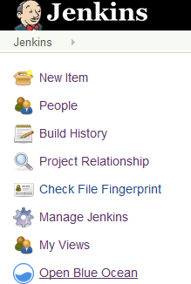

1. Click on Create Pipeline.

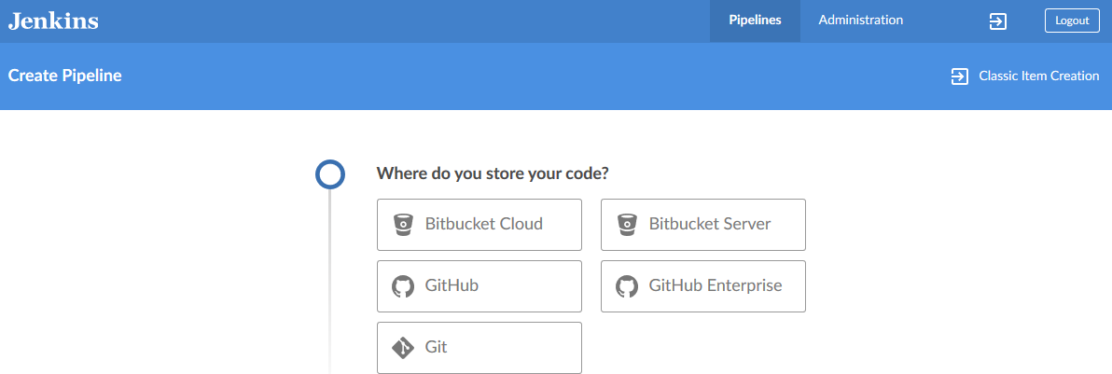

1. Specify the Source Code Management platform (Here, GitHub)
2. Authenticate GitHub using token and specify the repository to be used.
3. Create a unique pipeline name.

The Pipeline is created and it automatically starts the first build by finding the Jenkinsfile on the root of the repository.

**Output:**

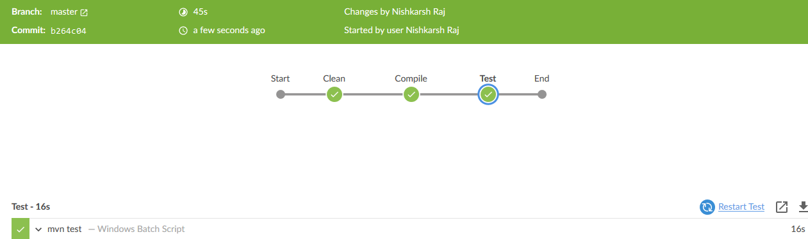

**Mvn Clean:**

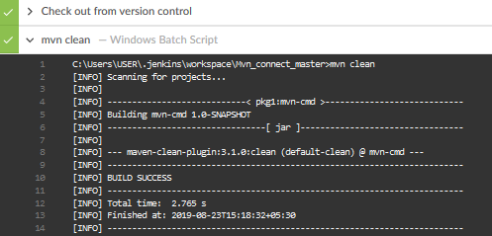

**Mvn test**

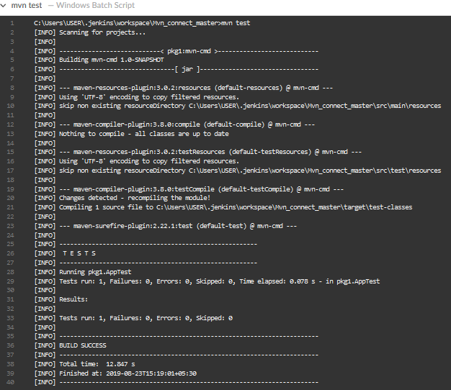

**Mvn Install**

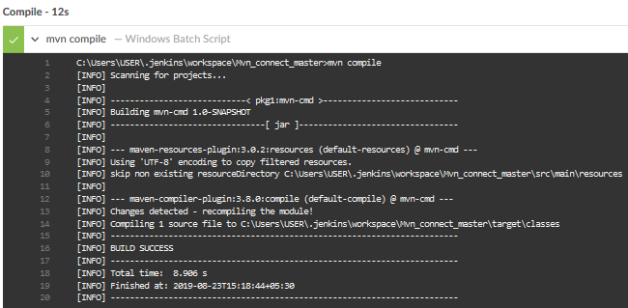

**Jenkinsfile Basics**

Following is the Jenkinsfile used in above project:

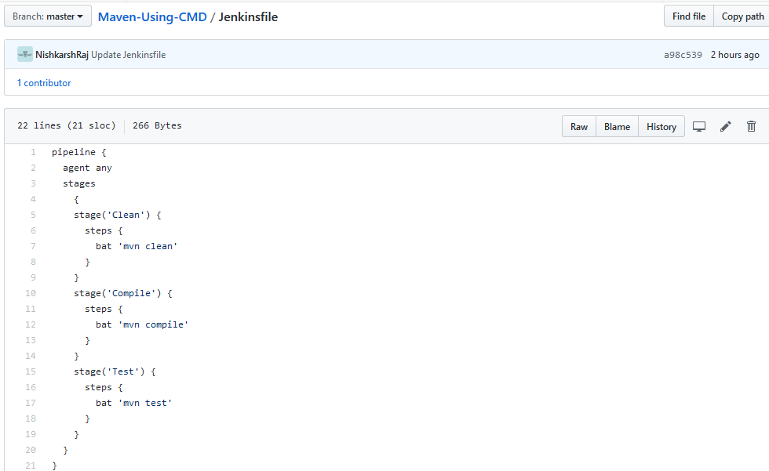

Here,

* **Pipeline** is the namespace
* **Agent any** can be treated as a class of functions.
* **Stages** include all the stages to be present in graphical form of pipeline.
* **Stage** includes name of the stage in pipeline along with the steps in performs
* **Steps** include the function and command the stage execute.

Note: “bat” is used for execution as Windows Batch command.

Similarly, “sh” can be used for Linux shell commands.